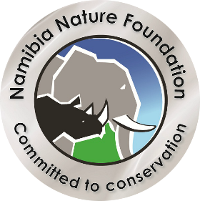
Namibia’s Go Green Fund

Namibia’s Go Green Fund, co-founded by Nedbank Namibia and the Namibia Nature Foundation in 2001, is a mutually beneficial partnership that supports nature conservation projects through community-based programmes.

Full Proposal
APPLICANT’S DETAILS:
Name: Initials:
Organisation:
Address:
Tel: Fax:
E-Mail:

PROJECT DETAILS (SUMMARY):
Project Title:
Location:
Project Duration – Start: End:

Project Outputs:

Project Background:

Project Aims:

Project Rationale:

Project Objectives:

Project Activities:

Project Goals/Outputs:

Mechanisms in place to measure achievement of goals (M & E):

Budget:
The budget should include the amount requested from the Namibia Go Green Fund, Other Sources including Own Contribution

Project | Total (N$) | Go, Green Fund | Total (N$)
Total |  | Total

How does this proposal meet the objectives of the Go Green Fund?

Project Workplan/Timeframe:

Example
Activities | Responsible person/supervisor | Quart I | Quart II | Quart III | Quart IV | Total | Site\venue

Select field which best fits project concept:

Climate Change Adaptation Habitat Conservation

Biodiversity Conservation Endigenous Plants

Coastal/Marine Natural History

Applicant: Signature: Date:

